**Circular Crystals Abstract Metal Wall Art**

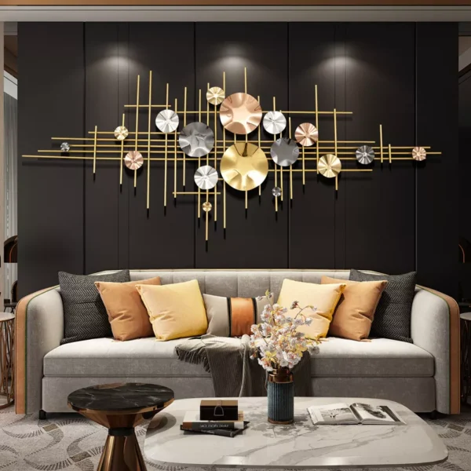Circular crystals abstract metal wall art is a dazzling fusion of modern design and shimmering elegance. Featuring intricately arranged circular forms adorned with crystal accents, this piece creates a stunning interplay of light and texture. The metallic framework, often in gold, silver, or black finishes, adds a sleek and contemporary touch, while the crystals enhance its luxurious appeal. Ideal for living rooms, dining areas, or entryways, this artwork serves as a captivating focal point, blending geometric precision with a touch of glamour. Its timeless beauty transforms any space into a sophisticated and radiant haven.